1.Create a P-T-S VPN and attach a VM to it

2.create a two web application in west us and central Us then attach to the traffic manager with Priority routing method

* First web application named as jackasswestus located in westus

* Second web application named as assjackcentralus located in centralus

* Traffic manager profile named as assessment2 with priority routing method

* Attaching web application (jackasswestus) which is located in west us to traffic manager (assesssment2)

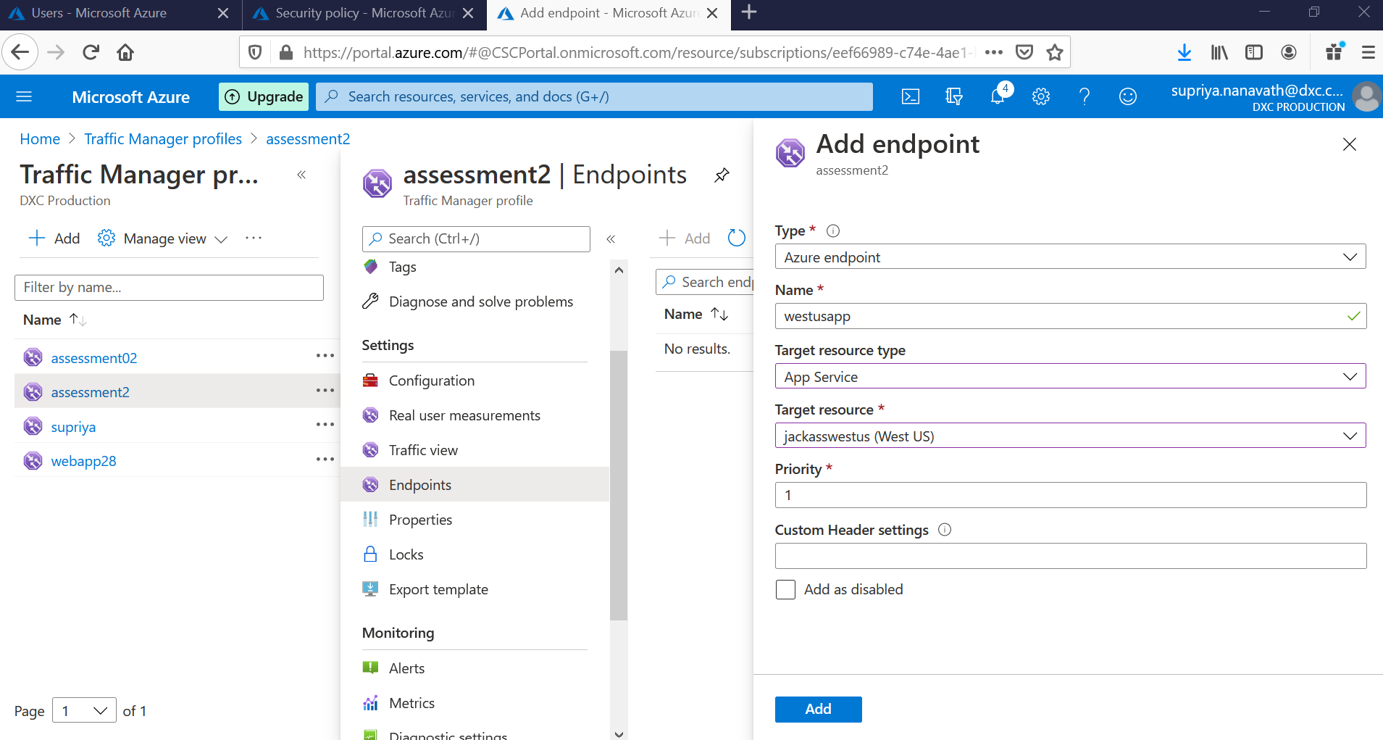

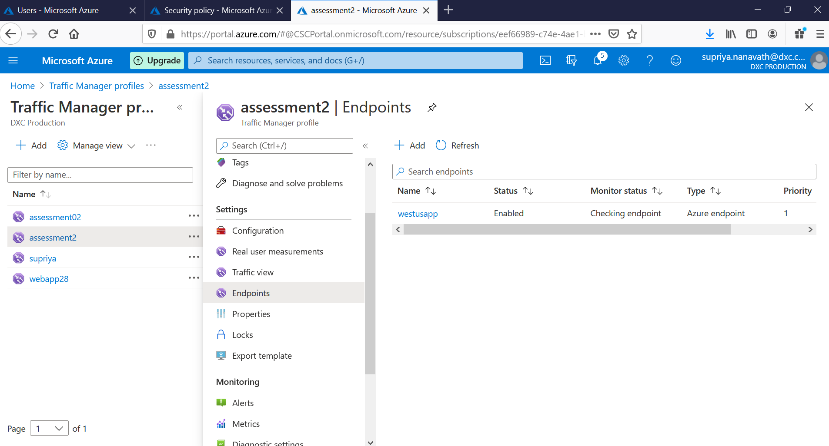

* Attaching web application (assjackcentralus) located in central us to traffic manager (assessment2)

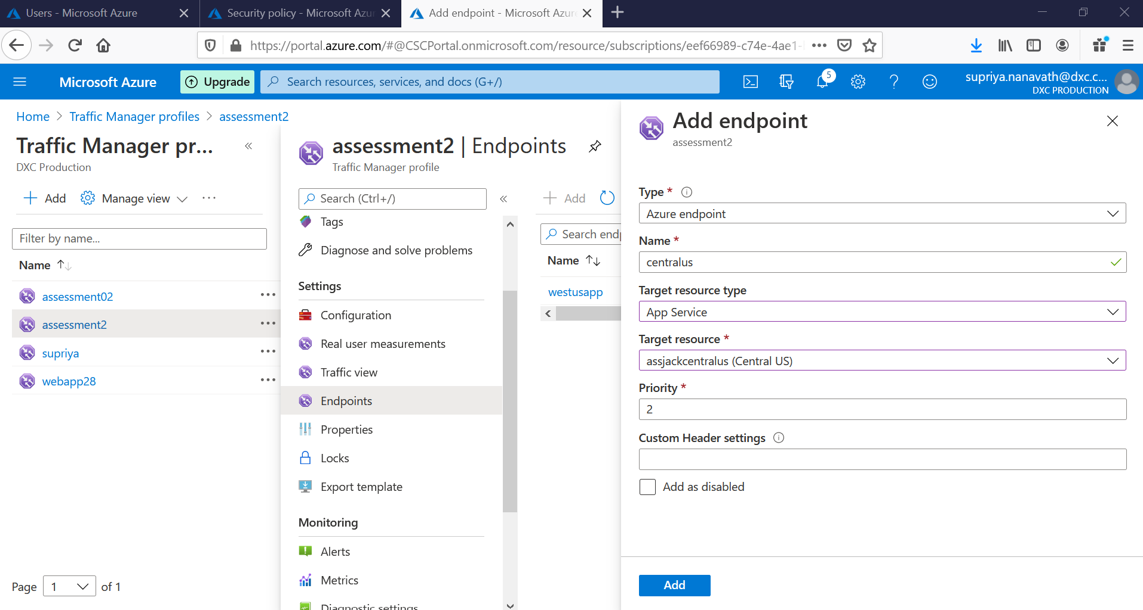

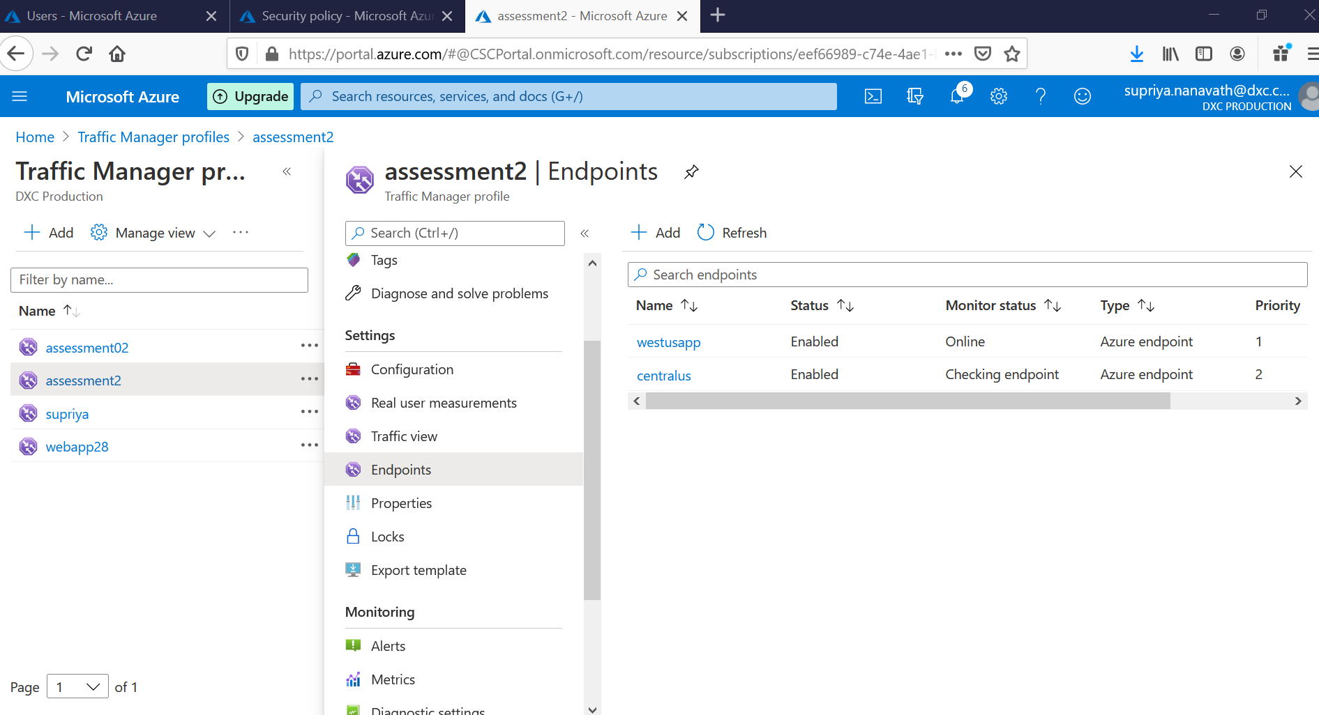

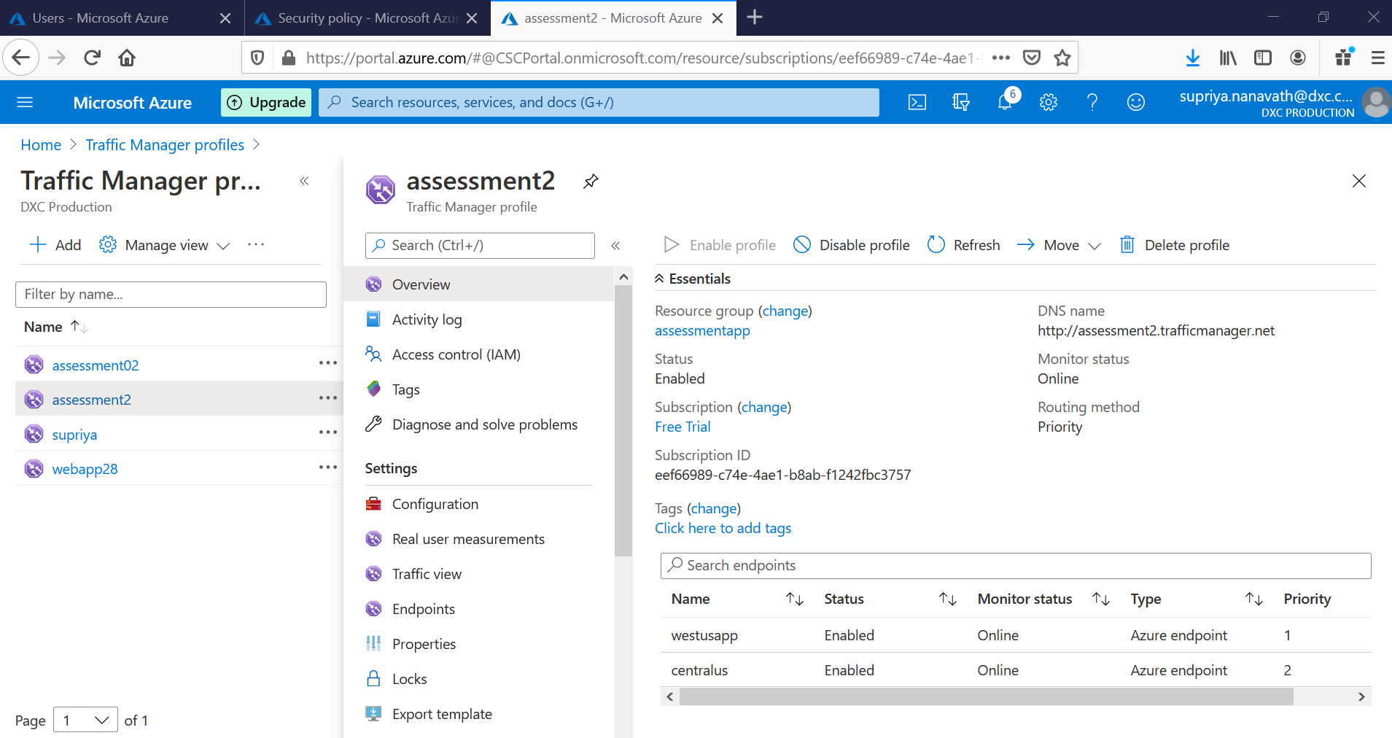

3. Create a windows server with AD installed and integrate with Azure AD

* Installed azure Azure Active Directory

* Integrating with Azure active Directory

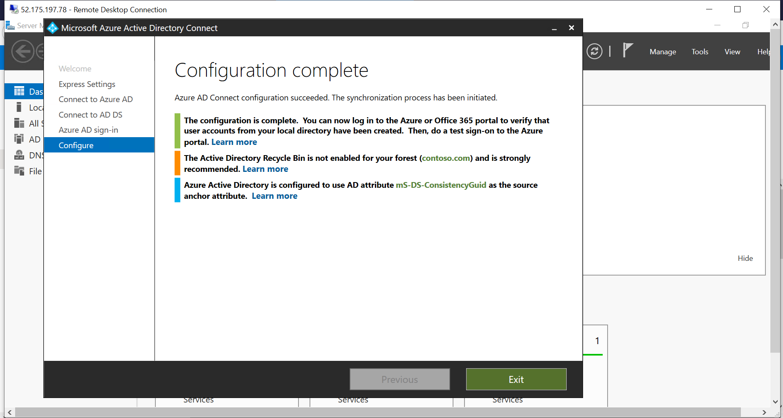

4.configure a backup to the VM you installed AD

* This is the VM in which we installed AD

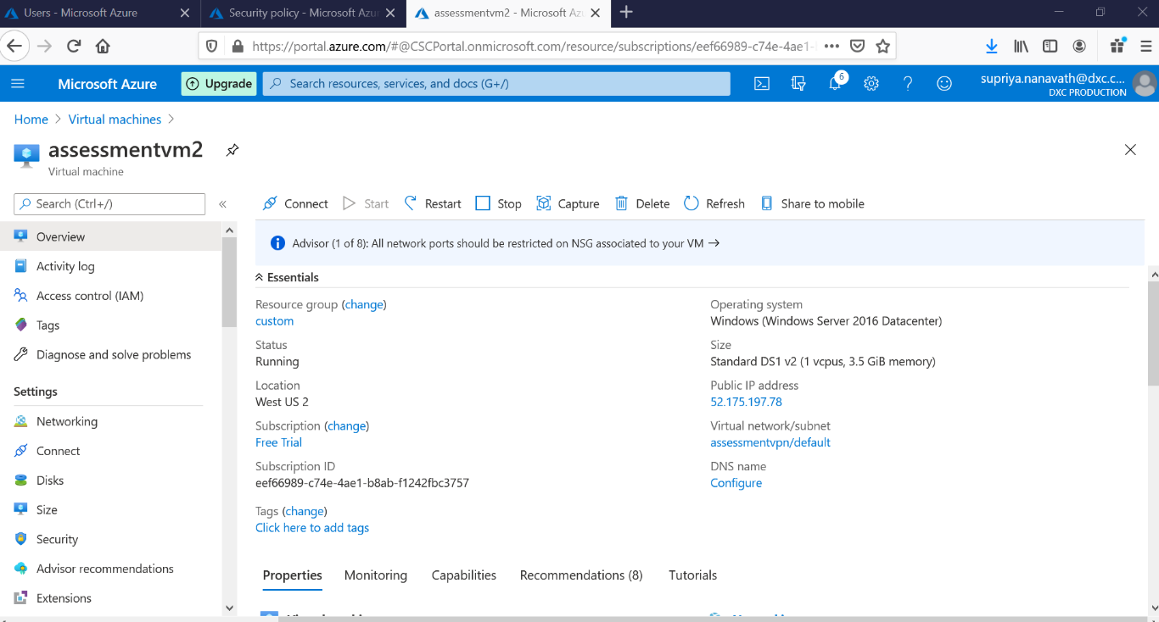

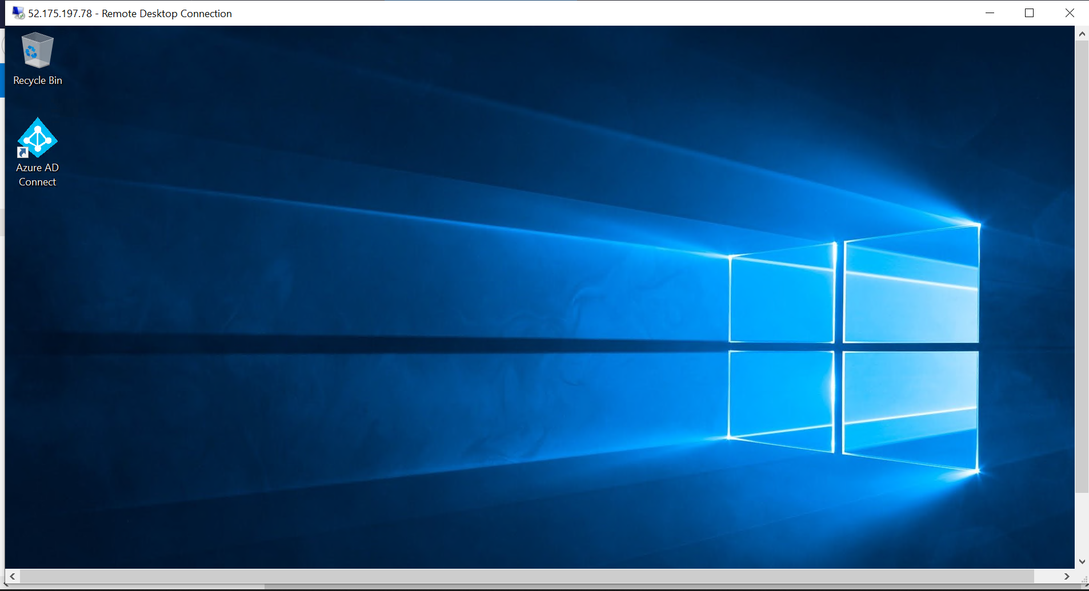

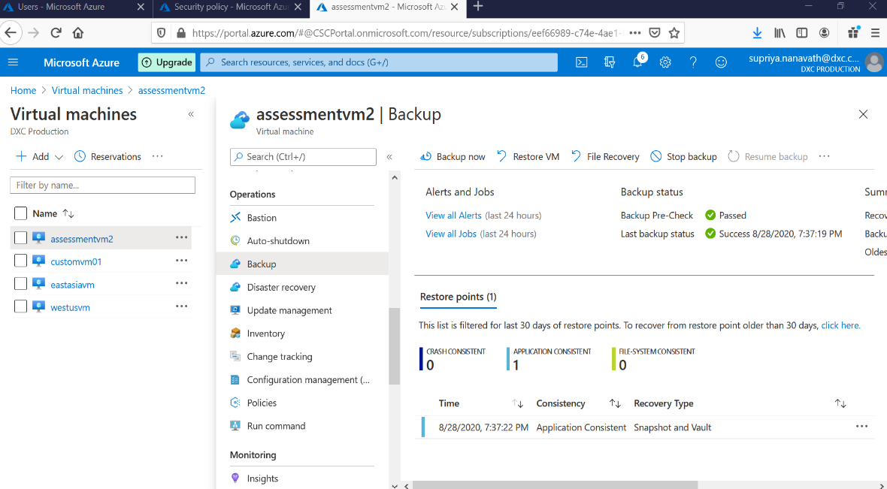

5.configure alerts for the VM

* Creating Alert rule in VM (assessmentvm2) and the I selected is CPU Credits Consumed

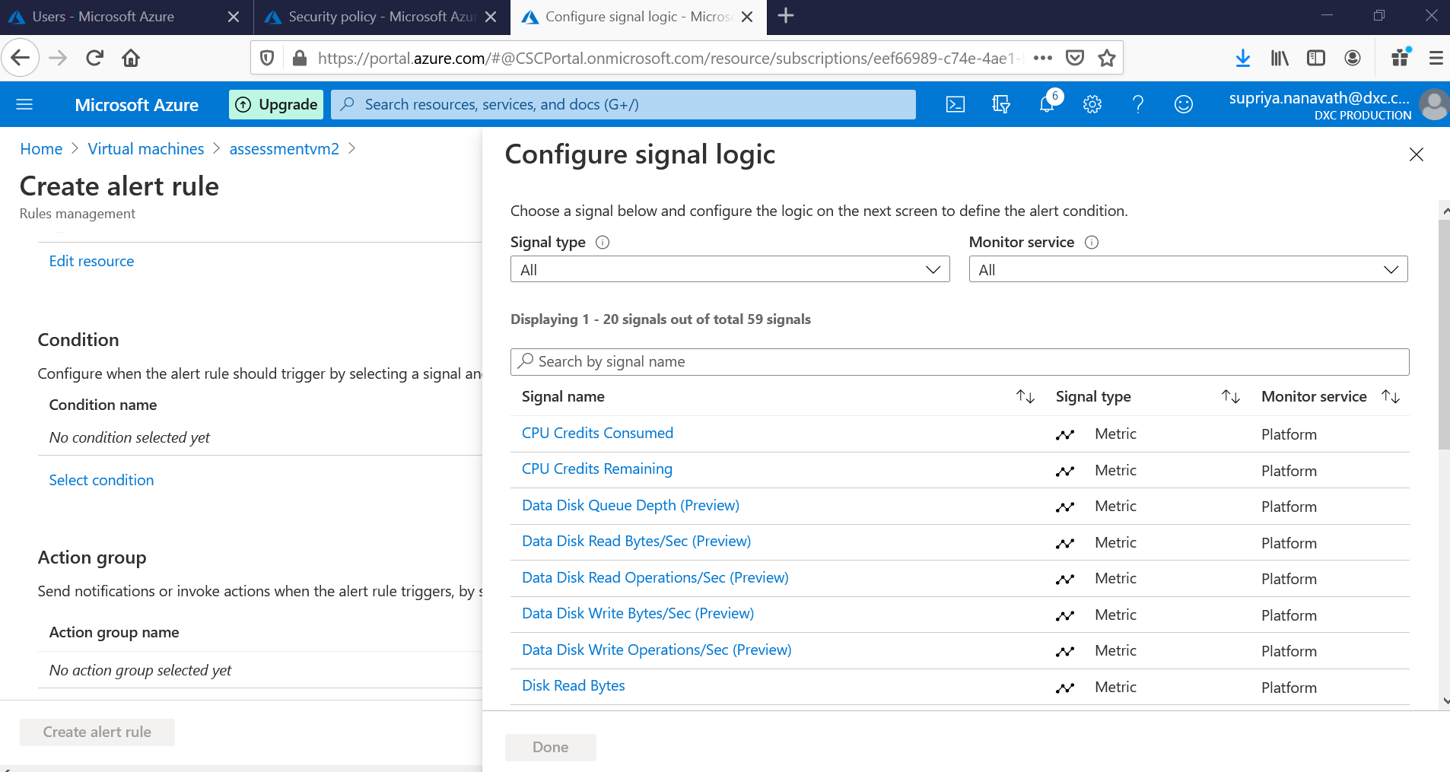

* Selecting condition for alert rule

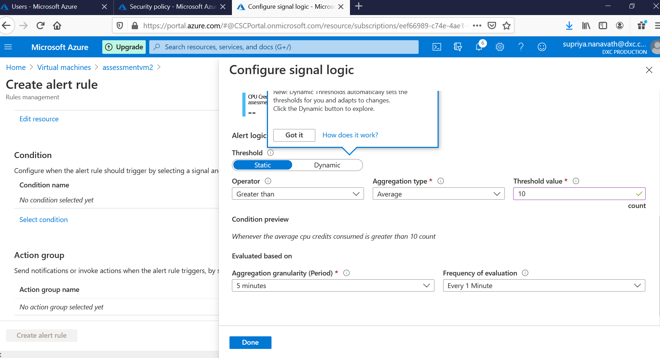

* Selecting Action group to assign Email ID or number to get alerts

6. Apply any security policy to the subscription

7. Create a SQL server with database installed in the elastic pool

* Created SQL with the name as assessment2

* Creating database and elastic pool

